02/12/2019

**Task:**

* Decompose the source signal in the real synodal using the discrete Fourier Transform
* Wrapped up ADXL357 application code
* Compare Results

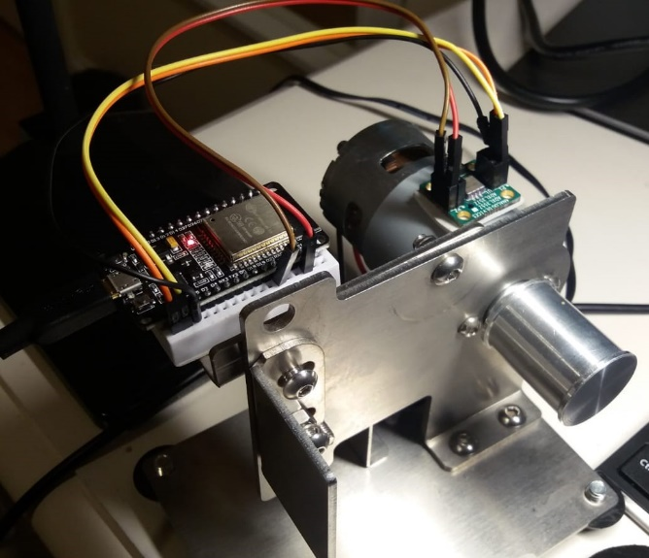**Issue:** For simulation and analyses I added the accelerometer sensor to the frame of a DC motor and changed the balanced from the shaft, what resulted in the vibration of the DC motor chassis.

Once the dc motor started, I noticed that the data packages stopped being transmitted and the python script crashed.

**Solution:** After investigation was noticed the SDA and SCL lines for I2C weren’t return to TTL High after reading execution. I researched in the ESP32 Forum and checked in schematics of the board and found that the internal pull-up resistor didn’t draw enough current to keep the lines active high. To solve it I add a 4.7KOhms resistor in SDA/SCL lines.

In that approach the current drawn increased to 0.7mA and was enough to hold the lines high.

**Test:**

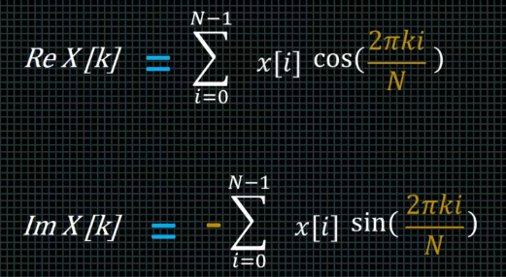The first test I performed the Discrete Fourier Transform algorithm decomposing and adding the complex coefficients of the input signal in imaginary and real sinusoids applying the mathematical expression:

Where 0 ≤ i ≤ N-1 and 0 ≤ k ≤ N/2

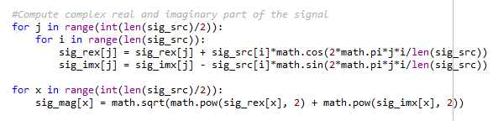

In this experiment I used 500 samples

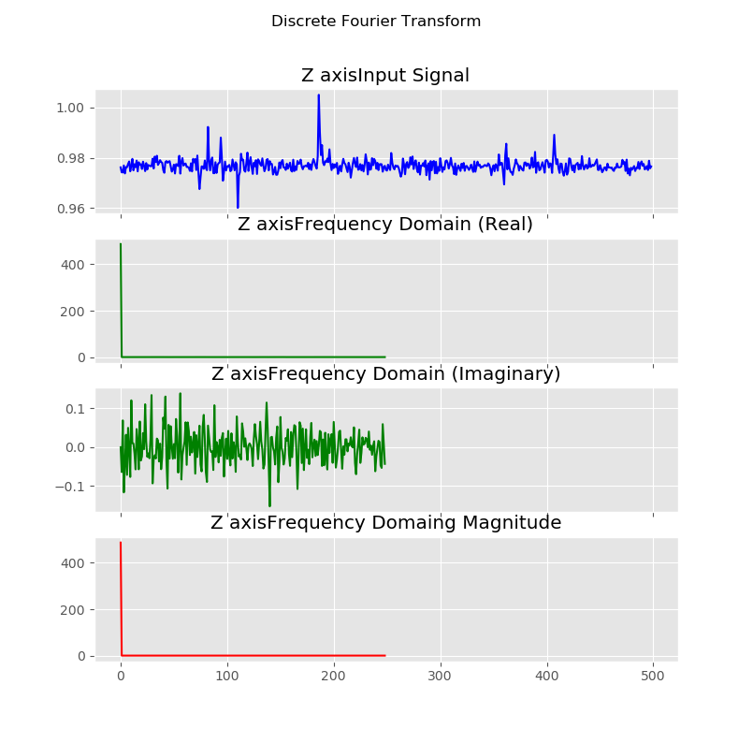

**References**

<https://github.com/espressif/arduino-esp32/issues/997#issuecomment-357546894> <https://www.geeksforgeeks.org/struct-module-python/>  
<https://learn.sparkfun.com/tutorials/i2c/i2c-at-the-hardware-level> <https://esp32.com/viewtopic.php?t=8356>  
<https://i2c.info/i2c-bus-specification#fast-mode>  
<http://www.robots.ox.ac.uk/~sjrob/Teaching/SP/l7.pdf>  
<https://matplotlib.org/>  
<https://numpy.org/>